Creating Custom Option Choices for Function Parameters

One of the things that I love about Visual Basic 6 is the way it always tells you what it is expecting. Where in most other languages, you are left guessing at the parameters a function is expecting and what data type they should be, VB shows you the choices right where they are needed. For example, If I am calling the function MsgBox to display a message box to the user, it looks like this as I enter the code:

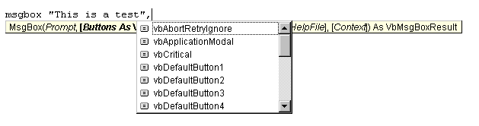The usefulness of this feature of the Visual Basic environment cannot be overstated. I often wished I could create such option lists for my own functions. Instead of writing a function like this:

Function SelectCustomerCategory (CustomerType as Integer) As String

Select Case CustomerType

Case 0
SelectCustomerCategory = “Corporate”
Case 1
SelectCustomerCategory = “Company”
Case 2
SelectCustomerCategory = “State Government”
Case 3
SelectCustomerCategory = “City Government”
Case 4
SelectCustomerCategory = “Federal Government”
End Select

End Function

I wanted to write it like this:
Function SelectCustomerCategory (CustomerType as Integer) As String

Select Case CustomerType

Case Corporate
SelectCustomerCategory = “Corporate”
Case Company
SelectCustomerCategory = “Company”
Case StateGovernment
SelectCustomerCategory = “State Government”
Case CityGovernment
SelectCustomerCategory = “City Government”
Case FederalGovernment
SelectCustomerCategory = “Federal Government”
End Select

End Function

But in order to do this, I found myself creating lots of constants like:
Const Corporate = 0
Const Company =1
Const StateGovernment=2
Const CityGovernment=3
Const FederalGovernment =4

Although this worked, once I had about 10 functions with five or six possible options, I started having trouble remembering which constants were defined for which functions. They would show up in the Options List if I pressed <ctrl> <space>, but since they were in alphabetical order, “Corporate “was miles away from the other constant “StateGovernment”.

Looking back, this all seems so useless, but at the time, I was very pleased with myself. Then one day I was reading a Visual Basics Standards book and discovered the “enum” data type. I have used User Defined Types (see my article on it by following the hyperlink) in QuickBasic and Visual Basic, so this seemed vaguely familiar. After reading about enum, I was delighted. It was exactly what I was looking for. With it you can define a set of parameters as a single data type and then “alias” the values with more understandable names (Like “Corporate” instead of “0”). When you select the parameter “Corporate” from the drop-down list, the aliased value of “0” is passed to the function. Sound cool? Read on and I will show you how do to it. It is actually very easy.

First, you must define the enum variable that will hold the values. In the declarations section of your form or module, add the following code:
Public Enum enCustomerType
Corporate = 0
Company = 1
StateGovernment = 2
CityGovernment = 4
FederalGovernment = 5
End Enum

There are some “rules” I need to point out about the above code.

- Of course, the name of your variable must be unique for the scope you are working in.
- The Enum data type can only accept Numerical values. Strings are not allowed. Corporate = “Corp” will not compile.
- The list can be as long as you like.
- The values do not have to be consecutive. They can be any numerical value.

Now for the function (This is the fun part):
Instead of using:
Function SelectCustomerCategory (CustomerType as Integer) As String

We are now going to use:
Function SelectCustomerCategory (CustomerType as enCustomerType) As String

So we are replacing the Integer data type with the enum type we created.

Complete your function:

Function SelectCustomerCategory (CustomerType as enCustomerType) As String

Select Case CustomerType

Case Corporate
SelectCustomerCategory = “Corporate”
Case Company
SelectCustomerCategory = “Company”
Case StateGovernment
SelectCustomerCategory = “State Government”
Case CityGovernment
SelectCustomerCategory = “City Government”
Case FederalGovernment
SelectCustomerCategory = “Federal Government”
End Select

End Function

That is all there is to it! Now try this:

Enter the following text in a form or module:

SelectCustomerType (

And watch what happens. You should see this:
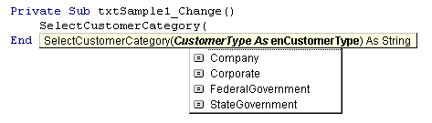You can then select one of you choices. When the function is called the value that you defined for the enum item will be passed. For example, if you select Corporate, the number 1 will be passed to the function.

Have Fun!

If you find this article helpful, please let me know by rating it at PlanetSourceCode.

